**DRGN STUDIOS Project Proposal**

**TEAM LEADER And Database Manager:** *Raushawn Mitchell*   
**Database Developer:** *Josiah Lawrence*   
**Website Developer:** *Aaron Hazzard*

**Selected Company:   
 -** NE1 Consultancy

**Company’s Vision:** To be the leading site for online freelancers in Trinidad and Tobago

**Team services offered:** Medium business size

**Expectations of team members:** Each member is expected to honour the contract that was signed and to work effectively as expected to run a successful business.

**Disciplinary action:** Any teammate that should disrupt or cause any type of chaos will be punished, this punishment can and will be decided on the context of the situation.

**Business Contact Information:**

* **Phone:** +1 (868) 279-3985
* **Email:** ne1creative.design@gmail.com

**INTRODUCTION**

NE1 Consultancy has a mobile application called NE1 that provides various services for freelancers across Trinidad and Tobago. However, their application is currently down due to failed services and features. Therefore, we decided to take the opportunity to create a Web Application cloned version of their Mobile Application so that they can continue their business.

**Situation**

This website is solely a platform to accommodate freelancers and provide them with the medium for which they can offer their services. It is also beneficial because of the increase in free-lances in terms of artists and other jobs.

**Project Objectives**

Our object with this project is to facilitate our clients and create job opportunities through a medium which we will attempt to create and will benefit their customers and our clients.

**Scope of project**

We are only obligated to follow the instructions that this document states, which will be making and designing a website for freelancers can use freely.

**Research methods**

We plan to provide the best and most unique services and options for our clients so that we can dominate the competition and be successful in this field. This will be done through an analysis of free-lancing websites and basing our research on how we could take their product and make it better and more desirable for our clients.

This is a sample website which we will take inspiration from and create a bigger and better product.

<https://www.fiverr.com/>

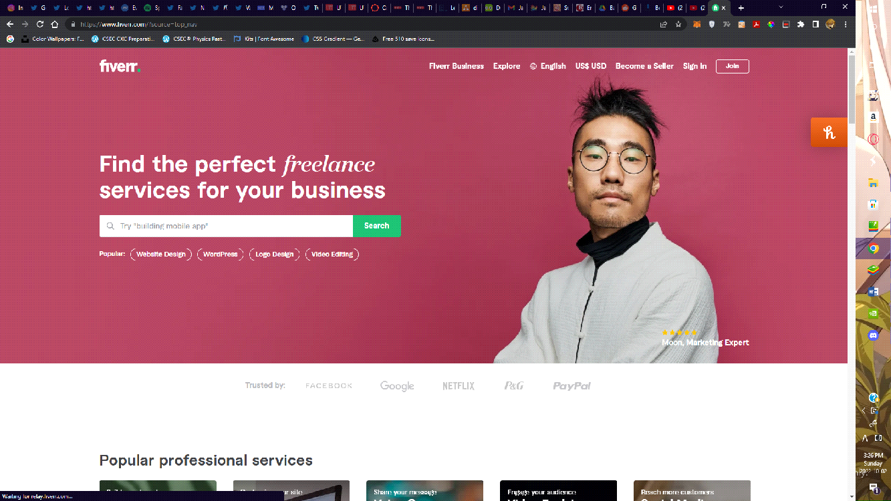

Functional Requirements

* Log in/Sign up System for user profiles
* User account settings
* Add profile pictire(optional)
* Ratings
* Forgot Password
* Create/Delete jobs
* Search for services
* Advertisements
* Contact Form
* Communicate with sellers(last)
* Display sellers info(cost, description of job)
* Allow sellers to post their service descriptions, fees and different plans
* Display most popular sellers(last)
* Freelancers’ details
* Keep track of online transactions
* Unique Sections for each genre of freelancers
* Hosting platform for the Website
* Premium features
* Invoice and distribution of money to clients

Non-Functional Requirements

* Minimum of 100TB of data to store
* Any device capable of browsing the web
* 24/7 Customer service support
* Maintenance and Monthly updates
* DBMS (Database Management System)
* The information must be fetched in less than a minute
* Easy to use GUI (Graphical User Interface)
* Daily system backups
* Advertise sellers

**EDUCATIONAL BACKGROUNDS**

*Josiah Lawrence:  
Caribbean Examinations Council (CXC)*

* Math
* English
* Chemistry
* Physics
* Spanish
* Technical Drawing
* Social-Studies

*Aaron Hazzard:   
Caribbean Examinations Council (CXC)*

* Math
* English
* Spanish
* PE
* Social-Studies
* IT

*Raushawn Mitchell:   
Caribbean Examinations Council (CXC)*

* Math
* English
* Economics
* Spanish
* Physics
* I.T
* Music

**CONTRACT**

*GROUP MEMBER RESPONSIBILITIES*

The success of this project is solely dependent on each member contributing and providing ideas or suggestions on how this should be done to have the best-desired result for success and complete the project criteria. the group members hereby agree to the following criteria to ensure effective productivity:

* Participate and contribute to the workload.
* Participate in a professional manner such as civil discourse and following the rules set out by the employer and following standards in business.
* Meeting deadlines and responsibilities such as completing given tasks in a timely manner and meeting the required specifications.
* Giving team members credit to boost their ego.
* Not giving credit to work that isn’t good so that they may improve.
* Cooperate even if conflicts occur.

After reading this document, once it is agreed upon, it should be assigned to finalize this agreement in ink.

_________________________   
*Raushawn Mitchell*  
**TEAM LEADER And Database Manager**

_________________________   
*Josiah Lawrence***Database Developer**

_________________________   
*Aaron Hazzard*  
**Website Developer**